Code Smells – Rodrigo Mesquita 57372

Smell Code Location:
\ganttproject\ganttproject\src\main\java\net\sourceforge\ganttproject\calendar\CalendarEditorPanel.java

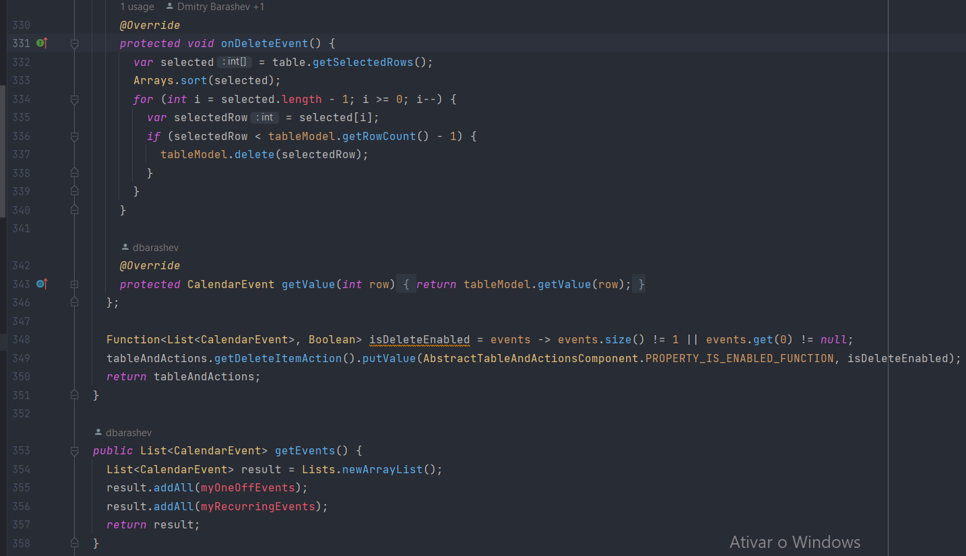
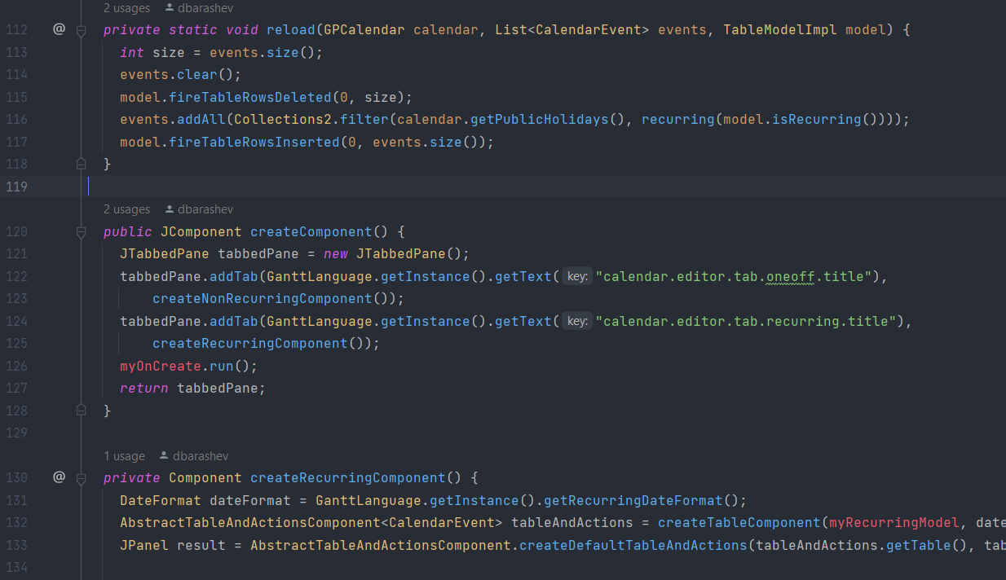
This class has 513 lines of code with many methods to for different purposes, but there are no comments to explain their functionalities, what makes it hard and exhaustive to understand the code to someone new or even to the original developer.
Smell Code Location:
\ganttproject\ganttproject\src\main\java\net\sourceforge\ganttproject\filter\GanttXMLFileFilter.java

This is an example of Dead Code. In this case, the class and its constructor are never used.

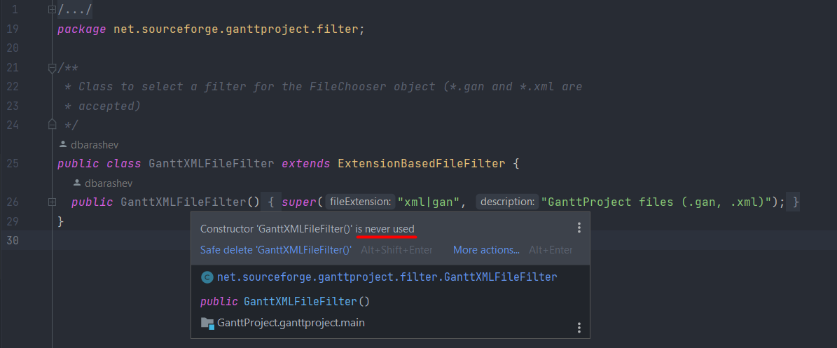

Smell code location:

